Importance of health spending in the Base of the Pyramid (BoP) population in Táchira, Venezuela

La importancia del gasto en salud en la población de la Base de la Pirámide (BoP) de Táchira, Venezuela

Julio C. Contreras-Velásquez¹; julio.contreras@tdea.edu.co Jorge Isaac García-Navarro²; jigarcian@gmail.com Zaida Rocío Contreras Velasquez³; José Alban Londoño Arias¹; jlondono5@tdea.edu.co Neida Albornoz⁴; Neida.albornoz@unisimon.edu.co Miguel Rosario Cohen^{4,5} Miguelrosariocohen@gmail.com Maritza Torres⁶; maritza.torres@saludzona6.gob.ec Lissé Angarita⁷; lisse.angarita@unab.cl Camilo Contreras⁸; camiloandrescontreras.v@hotmail.com Henry Garcia Pacheco^{9,10}; Henrygarciapacheco@gmail.com Valmore Bermúdez¹¹; valmore.bermudez@unisimon.edu.co
¹Administrative and Economic Sciences, Tecnológico de Antioquia Institución Universitaria, Medellín, Antioquia, Colombia.
²State management of the National Institute of Statistics (INE), Táchira, Venezuela. Universidad Católica, San Cristóbal, Venezuela.
³Universidad Francisco de Paula Santander, Cúcuta, Norte de Santander, Colombia.
⁴Facultad de Ciencias Jurídicas y Sociales, Universidad Simón Bolívar, Cúcuta, Colombia.
⁵Direction of Intellectual Creation, Doctorate in Management Sciences Universidad Sur del Lago. Santa Barbara del Zulia, Venezuela.
⁶Ministerio de Salud Pública de Ecuador, Centro de Salud Baños
⁷School of Nutrition and Dietetics, Faculty of Medicine, Universidad Andres Bello, Sede Concepción 4260000, Chile
⁸Universidad de Santander, Facultad de Ingeniería, Cúcuta, Colombia.
⁹Universidad del Zulia, Facultad de Medicina, Departamento de cirugía. Hospital General del Sur “Dr. Pedro Iturbe”. Maracaibo, Venezuela.
¹⁰Unidad de Cirugía para la Obesidad y Metabolismo (UCOM). Maracaibo, Venezuela.
¹¹Universidad Simón Bolívar, Facultad de Ciencias de la Salud, Barranquilla, Colombia.
Correspondence author: julio.contreras@tdea.edu.co; jcontrerasv16@gmail.com

Received: 06/24/2022 Accepted: 10/19/2022 Published: 11/25/2022 DOI: https://doi.org/10.5281/zenodo.7625661

Abstract
Introduction. This research analyzes whether health is among the three main expenditures that a household allocates from its income in the population at the base of the pyramid (BoP) and whether there is an association with people belonging to different socioeconomic levels of the BoP in the state of Táchira, Venezuela. Methods. Data was obtained from a structured questionnaire applied to a sample of 1,398 households in the Táchira region, Venezuela, which were classified by socioeconomic levels through the construction of a global synthetic index that, through scales, allows segmenting households by poverty conditions, from the most intense poverty condition to the most favorable non-poverty condition respectively, resulting in 675 households at the base of the pyramid. Results. For households at BoP levels 2 and 3, health expenditures are presented in greater proportion than in level 1, with a value of 55.74% and 51.77%, respectively, while in level 1 only 26.67% of households included health expenditures among the top three, likewise there is evidence of association between the BoP level and the categories of expenditures on housing, public services, health, and education. Conclusions. The multivariate method used to classify the socioeconomic level of people at the base of the pyramid, different from the traditional one, which uses a unidimensional selection criterion that defines the BoP as people with incomes of less than $3,000 per year.
Keywords: base of the pyramid, socioeconomic level, health spending, poverty.

Resumen
Introducción. Esta investigación analiza si la salud se encuentra entre los tres principales gastos que un hogar destina de sus ingresos en la población de la base de la pirámide (BdP) y si existe una asociación con las personas pertenecientes a los diferentes niveles socioeconómicos de la BdP en el estado Táchira, Venezuela. Métodos. Los datos se obtuvieron a partir de un cuestionario estructurado aplicado a una muestra de 1.398 hogares de la región de Táchira, Venezuela, los cuales fueron clasificados por niveles socioeconómicos mediante la construcción de un índice sintético global que, a través de escalas, permite segmentar los hogares por condiciones de pobreza, desde la condición de pobreza más intensa hasta la condición de no pobreza más favorable respectivamente, resultando 675 hogares en la base de la pirámide. Resultados. Para los hogares en los niveles 2 y 3 de la BoP, los gastos en salud se presentan en mayor proporción que en el nivel 1, con un valor de 55.74% y 51.77%, respectivamente, mientras que en el nivel 1 sólo el 26.67% de los hogares incluyeron los gastos en salud entre los tres principales, así mismo existe evidencia de asociación entre el nivel de la BoP y las categorías de gastos en vivienda, servicios públicos, salud y educación. Conclusiones. El método multivariado utilizado para clasificar el nivel socioeconómico de las personas de la base de la pirámide, difiere del tradicional, que utiliza un criterio de selección unidimensional que define a la BoP como las personas con ingresos inferiores a 3.000 dólares anuales.
Palabras clave: base de la pirámide, nivel socioeconómico, gasto sanitario, pobreza.

Introduction
Poverty is not evenly distributed around the world. In regions such as sub-Saharan Africa, South Asia and Latin America, millions of poor people struggle to survive (1). The unfair distribution of wealth and income has become a structural problem in most economies (2,3), mainly affecting people at the bottom of the pyramid (BoP), a population largely neglected in terms of solvent and stable solutions over time.
Latin America has 360 million people at the base of the pyramid and corresponds to the second-largest market in terms of income, with a figure close to $510 billion dollars. In addition, it is the region with the largest population-income gap, since 70% of the 360 million people together earn only 28% of the total regional income, demonstrating the inequality in income distribution that exists in the countries of the region (4).
Starting from the need raised in the previous paragraph, the article analyzes whether health is among the three main expenditures that a household allocates from its income in the population at the base of the pyramid and whether there is an association with people belonging to different socioeconomic levels in the region of Táchira, Venezuela.

Population of the BoP
From a demographic point of view, the BoP is a population living in several, mainly developing, countries, their common denominator being their low-income levels (5). If one classifies the world's population by its annual or daily disposable income as well as by its quantity, one obtains a pyramid-shaped distribution with very few rich people at the top and a huge base of poor people at the bottom (See Figure 1). These poor people represent the lowest level of the overall income pyramid and are therefore called the base of the pyramid (6,7). According to Prahalad (8) it is a population of 4.5 billion people worldwide who subsist on less than 3,000 US dollars a year.
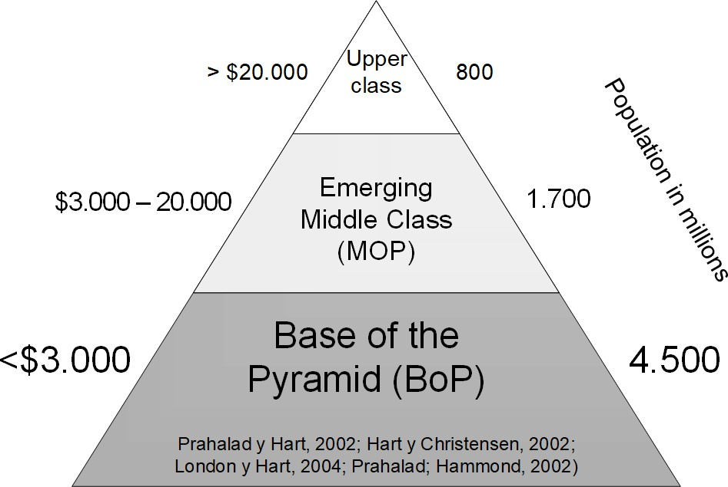

Figure 1. World economic pyramid
Source: Own elaboration

The BoP population varies between regions and countries (9), has characteristics such as cultural complexity and difficulty of access to products and services, especially in rural areas where there is physical isolation caused by inefficient investment in infrastructure (10).
Latin America is a region that represents 9.1% of the world's BoP population, comprising 360 million people with an estimated total income of 509 billion and a total expenditure of about 632 billion USD (11). According to studies by Guesalaga & Marshall (11), the category in which the BoP spends the most income is food, which in the case of Latin America has a percentage of 41% of total expenditures, followed by 14.5% in household expenditures (See Table 1).

Table 1. Distribution of BoP expenditure by geographic area and product category

Category | Africa | Asia | Europe | Latin  America | Total
Food | 47.1 | 55.3 | 56.8 | 41 | 53.2
Housing | 9.4 | 10.2 | 8.8 | 14.5 | 10.4
Water | 1.6 | 0.3 | 0.8 | 0.9 | 0.5
Energy | 5.9 | 6.2 | 7.2 | 5.5 | 6.2
Household Goods | 10.4 | 6.6 | 9.3 | 9.8 | 7.6
Health | 4.5 | 2.4 | 3.7 | 4.3 | 2.9
Transportation | 6.5 | 4.2 | 2.8 | 6.6 | 4.5
ICT | 1.2 | 1.3 | 1.3 | 2.2 | 1.4
Education | 2.8 | 2.0 | 1.2 | 1.6 | 1.9
Other | 10.6 | 11.5 | 8.1 | 13.6 | 11.4
Source: Guesalaga & Marshall (2008)

The lack of access to food products or the poor quality of those that are available to this population, produces poor eating habits and inadequate nutrient intake that affect physical health (12), as found by Daly & Leonard (13), where in 75% of low-income households, at least one member was in poor health; similarly, feelings of powerlessness can be reflected in psychological problems (14); For example, in a study carried out in the region of Zimbabwe by Chikweche & Fletcher (15), the people interviewed said that they must use the bar of washing soap as bath soap, even though it does not adapt to the sensitivity of the skin; cooking oil produced from by-products of the waste of the slaughtering process of animals for export, instead of vegetable oil; as well as consuming pieces of soya, instead of meat, sacrificing the content of proteins for an adequate nutrition.

Context of the Táchira region (Venezuela)
The Táchira region (Venezuela), according to the National Institute of Statistics of Venezuela (INE) has a population of 1,168,908 inhabitants, representing 4.29% of the national population (16).
It is made up of 29 municipalities grouped into five geographical zones as follows: Metropolitan Zone, integrated by the Metropolitan Area of San Cristóbal, which comprises six municipalities: San Cristóbal, Cárdenas, Guásimos, Andrés Bello, Capacho Nuevo and Capacho Viejo and the corresponding areas of influence; Border Zone, integrated by six municipalities: Ayacucho, Bolívar, García de Hevia, Junín, Pedro María Ureña and Rafael Urdaneta; Northern Zone, located in the northern plain of the State and integrated by six municipalities: Antonio Rómulo Costa, Panamericano, Samuel Darío Maldonado, Seboruco, Simón Rodríguez and San Judas Tadeo; Mountain Zone, made up of six municipalities: Francisco de Miranda, Jáuregui, José María Vargas, Lobatera, Michelena and the Sucre Municipality; Southern Zone, made up of the populated centers of the southern plain, considering five municipalities: Córdoba, Fernández Feo, Libertador, Torbes and Uribante (16).
Figure 1 shows the location of the Táchira region in Venezuela, as well as the geographical distribution of its municipalities.
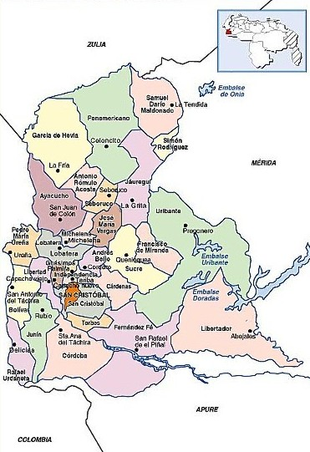

Figure 2. Map of the Táchira region (Venezuela)

- Methodology
Population and sample

The statistical unit of analysis of the data collected is the household, distributed in the geographic zones of the state of Táchira. To determine the size of the sample, the population distribution of the six geographic zones of the department of study was considered. The type of sampling used is probabilistic stratified multistage with systematic random selection in the primary sampling units (segments); followed by secondary units (blocks) and, finally, the final observation unit (households).

The strata are represented by the geographic zones defined by each municipality, which is weighted according to its population size, which in turn contain the clusters of the first selection (segments) within these, the clusters of the second selection (blocks) that contain the observation units (households).
The sample size is estimated through the sampling formula of proportions in finite populations:

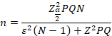

Where, the N is equal to 252,409 households, with a confidence interval of 95%, a maximum admissible error of 3% and considering the maximum dispersion of the key variable P and Q both with a value of 0.5. The size of the initial sample was 1,066 households; to ensure the efficiency, sufficiency and precision of the sample, an oversampling system was adopted that considers an "adjustment by design," which guarantees the execution of the sample with the sizes estimated as minimum within the levels of confidence and maximum permissible error. The system consists of applying a non-coverage factor (t) to the sample sizes (n) estimated for each of the zones, with which it was determined that the final operative selection size is 1,398 households.

Table 2 shows the results for the State of Táchira and geographic zones, as a result of the design adjustment process.

Table 2. Sample distributed by geographical areas

Geographical areas | Number of households | Sample no.0 | Design- adjusted effective sample n
Metropolitan | 125,968 | 532 | 560
Mountain | 16,167 | 68 | 147
Border | 69,432 | 294 | 382

North | 15,185 | 64 | 150
South | 25,657 | 108 | 159
Total Táchira | 252,409 | 1,066 | 1.398

Source: Own elaboration

BoP segmentation method

People of the same social class are roughly equal in terms of their income and social status, work in roughly equal occupations, and tend to have similar tastes in some products and services. They also tend to socialize with each other and share many ideas and values (17).

The unidimensional method of classifying households by socioeconomic levels through income has been the most widely used; however, it presents difficulties that generates limits and bias over the analysis, due to measurement errors such as under-declaration and non-declaration of income information (18,19;20,21,22), or the difficulty in quantifying income by period when people have an informal job (23,24). At the same time, if we want to make comparisons between different developing countries, using the economic parity technique, the volatility in macroeconomic indicators and exchange rate policies, as in the case of Venezuela, make the analysis difficult (25).

In this study, the methodology consists of the construction of a global synthetic index that, through scales, allows segmenting the households by poverty conditions, from the most intense poverty condition to the most favorable non-poverty condition respectively. To arrive at the index, an Optimal Quantitative Valuation of a set of variables associated with the living conditions of the households in the sample of Táchira is carried out (26).

Given that we have ordinal categorical variables, we assign values to each of the categories of the variables and then observe which households have similar qualities with respect to a set of variables. The technique used is that of optimal scaling by alternating least squares, using the technique of principal components analysis for categorical variables, Categorical Principal Components Analysis (CATPCA); which allows obtaining the quantification results of score coefficients of tenure or deprivation assigned to each one of the households (27).

To quantify the categorical variables, the codes of the categories are replaced by optimal numerical values, to be able to determine the existing relations between them (28). The process of quantitative valuation of the categories is carried out in pairs, using the optimal scaling method according to alternating least squares, where it is iterated in two stages, in the first one the model is estimated and in the second stage, the optimal scaling is carried out. These two stages are alternated iteratively until a certain convergence is achieved. The optimal scaling level of the variables is ordinal, so that the transformed values represent ordered categories (27,26).

After obtaining the score coefficients, the second multivariate technique, k-means cluster analysis, is applied, where households are classified into socio-economic levels by groups with similar characteristics ranging from the most intense poverty condition to the most favorable non-poverty condition respectively. The procedure is explained in detail below.

Data analysis and results

  - . Segmentation of the Base of the Pyramid Households

    - Selection of variables associated with living conditions

Based on the studies carried out by Camardiel (27); Vyas & Kumaranayake (29), the variables associated with the selected living conditions and their indicators for the construction of a synthetic poverty index, are:

- Structural characteristics of the household: Floor material, Wall material, Ceiling material, Number of bathrooms, Number of bathrooms with shower, Sleeping rooms.

- Access to household services: Electricity service, Cooking fuel, Urban sanitation service, Excreta disposal (sewage), Drinking water service, Fixed telephone at home.

- Household equipment ownership: Refrigerator ownership, Kitchen ownership, Number of TV sets, Cable TV ownership, Internet ownership.

- Assets: Home Ownership, Number of cell phones, Number of Vehicles, Number of motorcycles.

- Socioeconomic Characteristics: Level of Occupation (Employed or Unemployed), Educational Level of head of household.

    - Transformation of Original Variables by Optimal Scaling

The procedure is based on the assignment of numerical values to the categories of each variable, in order to subsequently analyze the scale of measurement of the variables with the optimal scaling technique. The final value of the quantified variables depends on the scaling level. In order to preserve the ordinal value of the original variables, the transformations of each variable are represented as category points on a vector passing through the origin.

The relationship between the quantifications and the original categories resulting from the selected optimal scaling is shown by the ordinal scaling transformation plots (See Figure 3),
where the horizontal axis is the original category code, and the vertical axis represents the optimal quantifications, the greater the slope between categories, the greater the importance.

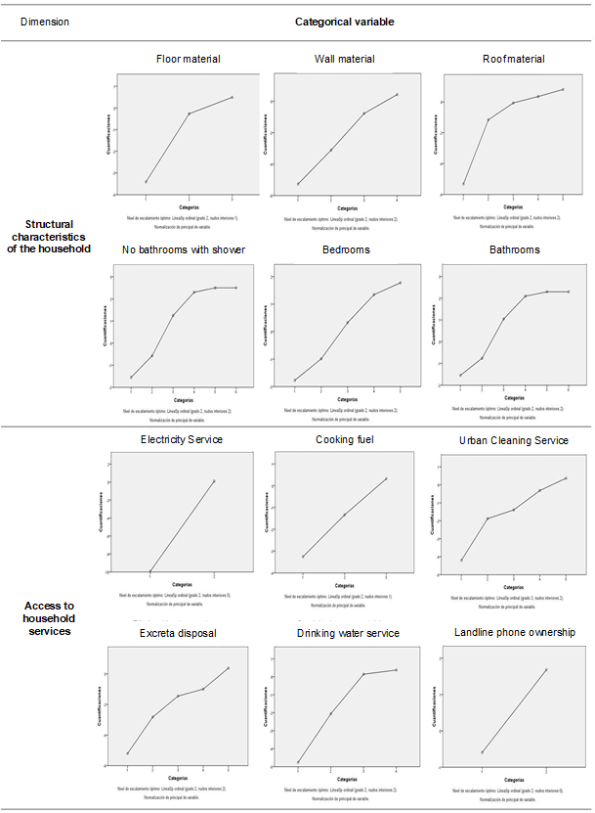

Figure 3. Ordinal Categorical Variables Transformation Plots
Source: Own elaboration based on SPSS results.

    - Quantification of qualitative variables and assignment of scoring coefficients to households

Given the qualitative nature of the variables under study, measured in nominal and ordinal scale, conducive to the construction of a synthetic index capable of measuring and segmenting the socioeconomic level of the households, the method of the algorithm of optimal scaling level by alternating minimum squares is applied, through the technique of analysis of principal components for categorical variables, Categorical Principal Components Analysis (CATPCA), which allows obtaining in numerical value the score coefficients of tenure or lack assigned to each one of the households (30,31).

To quantify the categorical variables, the codes of the categories are replaced by optimal numerical values, in order to determine the existing relations between them (28). The process of quantitative valuation of the categories is carried out in pairs, using the optimal scaling method according to alternating least squares, where it is iterated in two stages. In the first stage, the model is estimated and in the second stage, the optimal scaling is performed. These two stages are alternated iteratively until a certain convergence is achieved. The optimal scaling level of the variables is ordinal, so that the transformed values represent ordered categories (26,27).

The number of principal components to extract is defined by the researcher and a common rule is to select those components whose associated eigenvalue is greater than one. However, for the construction of socioeconomic levels, it is assumed that the first principal component captures the greatest variability.

The eigenvalue of each principal component indicates the percentage of variability in the total data that is explained. In other studies, the first component explains between 12% and 27% (32), between 13% and 16% (29) and 26% (33). Although these percentages are not high, they indicate the complexity of the correlations between the variables.

The estimation of the model obtained is presented in Table 4, where the total percentage of variance explained is 25.64%, that is, it is the total information retained or explained by the two dimensions of the model, where the variables of dimension 1 contribute 15.372% and dimension 2 retains 10.271%. The Cronbach's alpha coefficient of both dimensions is positive, which allows us to observe accumulation of information above the average of the model in other studies.

Table 41. Model estimation of the optimal scaling method

 | Cronbach's Alpha | Variance posted for
Dimension | Cronbach's Alpha | Total (eigenvalue) | %  variance
1 | 0.738 | 3.382 | 15.372
 | 0.584 | 2.260 | 10.271
Total | .862a | 5.641 | 25.643
a. The total Cronbach's alpha is used in the total eigenvalue.

Source: Own elaboration based on SPSS results.

Once the consistency of the optimal scaling model has been verified, we proceed to determine the two dimensions or principal components, which are new variables, in this case two, that allow us to reduce the dimensionality of all the variables. By analyzing Figure 4, it can be inferred that dimension 2 represents asset holding variables, while dimension 1 represents variables of structural conditions and access to household services.
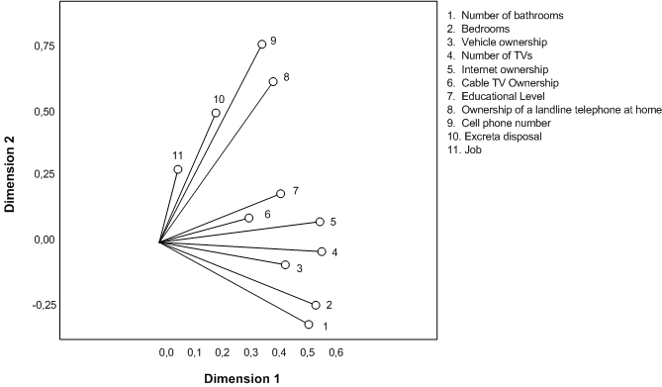

Figure 4. Variable’s saturation graph by dimension
Source: Own elaboration based on SPSS results.

Figure 5 shows the quantification of the categories of the variables on a map. The interpretation of the plane with the vectors of each category is carried out based on the following guidelines: 1. The close categories imply the same combination of responses; 2. The distant categories imply different patterns of responses; 3. The variables of which their answers are a line imply association; 4. The variables of which their answers are a perpendicular line, imply independence.

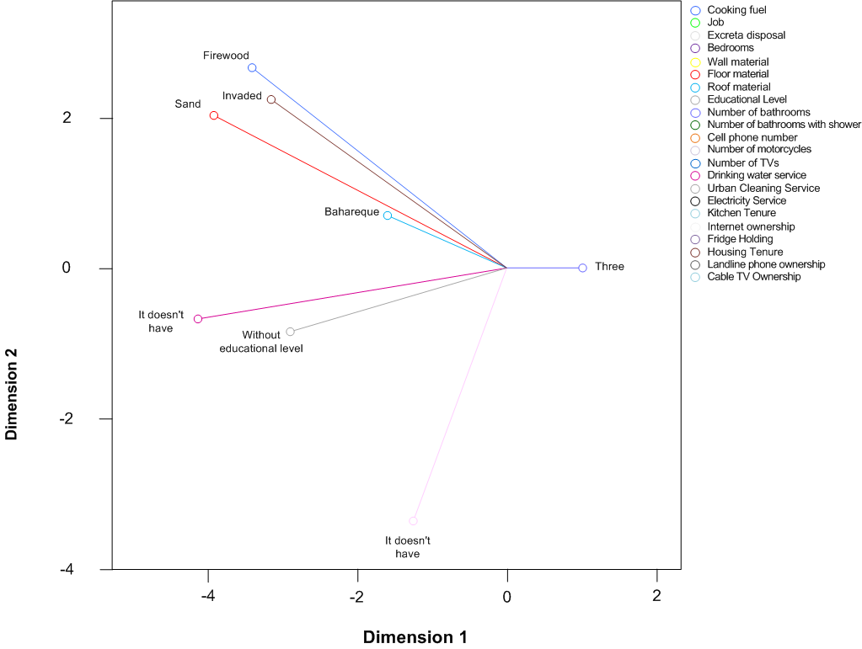

Figure 5. Category Point Charts
Source: Own elaboration based on SPSS results.

The graph of category points represented by the coordinates of the vectors in the two- dimensional plane allows for the analysis of possible associations or patterns of relationships.

Figure 5 shows on the upper left side, clearly differentiated relationship patterns between absence of services such as cooking fuel, electricity, urban sanitation, excreta disposal, also precarious conditions in the housing structure, as well as low level of education; while on the other upper right side of dimension 1 there are patterns of association between asset ownership, better conditions in education and access to basic essential services.
    - Construction and standardization of the Socio-Economic Level Index (INSE)

The construction of a synthetic index that represents the socioeconomic score of households is based on the optimal quantifications of the evaluated variables resulting from the categorical principal components analysis. The index can be defined as a dependent variable, from the linear combination of the vectors that define each of the categories within each variable.

Let Ŷjk be the optimal categorical quantifications of the J variables which is equivalent to 23 variables, with j = 1, ..., m and of the k-th category within each variable. For example, Ŷ₂₃ is the quantification of variable 2 corresponding to Floor material of the third category which is Cerm/gran/parq.

In this way we obtain a vector Ŷ which is formed by the quantifications Ŷ_{1k} , ... Ŷ_{jk} , ... Ŷ_{mk} ,
represented in Equation 1.

Ŷ = (Ŷ_{1𝑘}, … Ŷ_{𝑗𝑘}, … Ŷ_{𝑚𝑘} ) | Equation 1

For the case of the first variable Ŷ_{1k} which has s1 categories, i.e., the vector of quantifications of the first variable is shown in Equation 2.

Equation 2

Within each variable a minimum of the optimal quantifications is defined to order the weights (See Equation 3).

Equation 3

The value of the next quantization to the minimum will be given by Equation 4, where ẟi is a scalar that measures the difference between a smaller and a larger quantization with i = 1, ..., k-1, i.e., for example ẟ1 measures the difference that exists between the minimum and the second quantization with respect to the values given by the algorithm.
Equation 4

When obtaining the quantifications on the scale from zero to a maximum value within the variable, the sum of these maximums is performed as shown in Equation 5.

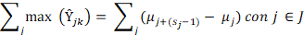 | Equation 5

In order to guarantee the ordinality from lowest to highest of the categorical quantifications of the components of the vector Ŷjk and to facilitate the reading of the values of the global index and of the partial indexes of socioeconomic level, a typification is carried out so that the global index takes values between 0 and 100, where the lower limit represents the most intense poverty condition and the upper limit, the best non-poverty condition (27).

On knowing the highest possible value that a household can have with respect to the variables studied, a scaling factor is obtained, which is the result of dividing between the desired scale, in this case 100, and the highest possible value, as shown in Equation 6. The data obtained are presented in Table 5.

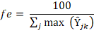 | Equation 6

Finally, the Socioeconomic Level Index (INSE) is obtained, imputing to the categories the corresponding valuation by adding the scores in each household, applying Equation 8.

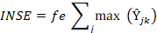 | Equation 1

    - Classification of households into socio-economic groups

The classification method used is cluster analysis, which aims to conglomerate the observations into groups that are internally homogeneous and heterogeneous among them. The technique used is cluster k-means, where the grouping is done by minimizing the sum of quadratic distances between each observation and a centroid of its group or cluster. The number of groups or centroids is defined by the researcher, for this study each group represents a socioeconomic level.

The number of socio-economic levels or groups defined is four, ranging from the most intense poverty condition to the most favorable non-poverty condition respectively. A first level that represents extreme poverty, the second, third and fourth levels represent three levels of the
BoP as proposed by Guesalaga & Marshall (11); Hammond et al. (34) in their studies, and the fifth level that groups the middle and upper class households; this is how the four levels are obtained: 1. Extreme Poverty; 2. Level 1 BoP; 3. Level 2 BoP; 4. Level 3 BoP and 5. Middle and upper class.

After applying the k-means clustering technique, with k = 5, Figure 6 is obtained, where the codes for each observation that were located on the map are grouped into each of the defined socioeconomic groups or levels.
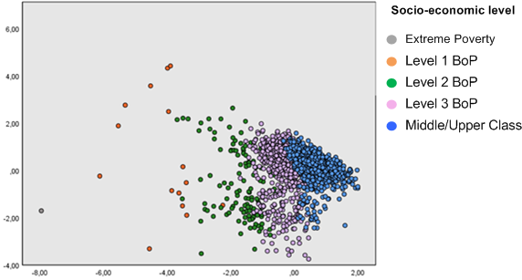

Figure 6. Households by socioeconomic level at Táchira
Source: Own elaboration based on SPSS results.

The quantitative interpretation of Figure 6 is summarized in Table 5, which shows the ranges of the INSE obtained for each socioeconomic level of the households in the Táchira region, after applying the k-means cluster technique. If the household has an SESI between 0 and 30.24 points it is classified as Extreme Poverty; between 30.25 and 66.71 points it is considered Level 1 BoP; between 66.72 and 78.24 points it is considered Level 2 BoP; between 78.25 and 86.02 points it is classified as Level 3 BoP; and between 86.03 and 100 points it is considered Middle and Upper Class.

Table 5. Classification of households by socioeconomic level at Táchira
INSE Rank | Socioeconomic level | Frequency | Percentage | Cumulative percentage
Between 0 and 30.24 | Extreme poverty | 1 | 0,1% | 0,1%

Between 30.25 and 66.71 | Level 1 BoP | 15 | 1,1% | 1,1%
Between 66.72 and 78.24 | Level 2 BoP | 123 | 8,8% | 9,9%
Between 78.25 and 86.02 | Level 3 BoP | 537 | 38,4% | 48,4%
Between 86.03 and 100 | Middle and Upper Class | 722 | 51,6% | 100,0%
 | Total | 1398 | 100,0%
Source: Own elaboration based on SPSS results.

Figure 8 shows graphically the socioeconomic pyramid of households in the Táchira region, where each socioeconomic level is distributed as a percentage, after applying the multivariate method of living conditions. The sample of n= 1398 from Táchira, was segmented by socioeconomic level by 272 (19.5%) upper class households, 450 (32.2%) middle class, 675
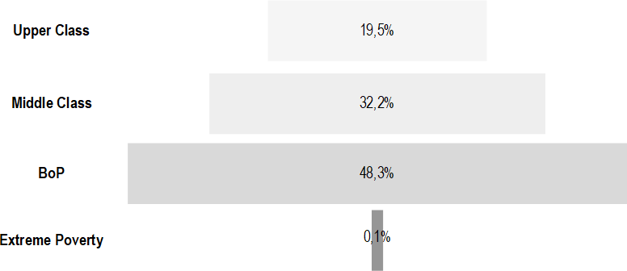
(48.3%) BoP and 1 (0.1%) extreme poverty.

Figure 8. Socioeconomic pyramid in households at Táchira
Source: Own elaboration

5.2. Income expenditure by category of services or products in BoP households in Táchira, Venezuela

With respect to the destination of household income expenditure, Table 6 shows which categories of products or services are among the three most important for households, depending on their socioeconomic level. It is evident that for households in levels 2 and 3 of the BoP, health expenditures are presented in greater proportion than in level 1, with a value of 55.74% and 51.77%, respectively, while in level 1 only 26.67% of households included health expenditures among the three most important.

It also shows whether or not there is an association between the variables expenditure category and socioeconomic status of the BoP. Values in the same row and subtable that do not share the same subscript are significantly different at p<0.05 in the bilateral test of equality
for column proportions, i.e. it is inferred that there is an association between the two variables. Thus, the categories that have an association between the two variables are housing, public services, health and education.

Table 6. Association between Expenditure Category and socioeconomic status of the BoP

Category | Socioeconomic Level BoP |  |  |  |  |  |  |  |  | Total
Category | Level 1 |  |  | Level 2 |  |  | Level 3
Category | Absolute Frequency | Relative Frequency % |  | Absolute Frequency | Relative Frequency % |  | Absolute Frequency | Relative Frequency % |  | Absolute Frequency | Relative Frequency %
Housing | 6 | 40.00_{a} |  | 33 | 27.05_{a} |  | 107 | 19.93_{a} |  | 146 | 21.66
Food | 15 | 100.001 |  | 118 | 96.72_{a} |  | 532 | 99.07_{b} |  | 665 | 98.66
Public Services | 6 | 40.00_{a} |  | 59 | 48.36_{a} |  | 310 | 57.73_{a} |  | 375 | 55.64
Clothing | 3 | 20.00_{a} |  | 11 | 9.02_{a} |  | 61 | 11.36_{a} |  | 75 | 11.13
Healthcare | 4 | 26.67_{a} |  | 68 | 55.74_{a} |  | 278 | 51.77_{a} |  | 350 | 51.93
Transportation | 2 | 13.33_{a} |  | 19 | 15.57_{a} |  | 94 | 17.50_{a} |  | 115 | 17.06
Education | 2 | 13.33_{a} |  | 20 | 16.39_{a} |  | 104 | 19.37_{a} |  | 126 | 18,69

- Discussion and implications

This study discussed whether the health expenditure of the population at the base of the pyramid is among the main destinations of their income and whether there is an association between this and the socioeconomic level of the BoP in the Táchira region of Venezuela. The results provide relevant information about a population that represents the majority in developing countries. The first finding confirms the above,and is that by applying the multivariate segmentation technique we obtain that 48.3% of the households belong to the BoP. In addition, the use of this technique facilitates the standardization to classify the target population of the study, allowing to mitigate the difficulties of the traditional univariate method by income below 2 USD proposed by Prahalad, thus facilitating the comparative analysis between different developing countries.

Although the income level of the study population is low, it can be inferred that for more than half of the households surveyed in Táchira in levels 2 and 3 of the BoP, health is one of the main expenses where they spend the low income they obtain.

The results of this research also confirm the theory that the BoP population is heterogeneous due to socio-cultural differences as the one carried out by Thakur (9) in Asia, evidenced in the association that exists between health expenditure and socioeconomic level, when rejecting the hypothesis of independence, which means that the proportion of households that consider health expenditure important varies depending on which level of the BoP they are in.

It is hoped that this study will motivate the academic community to continue researching the population that most represents the countries of the region, so that the results can serve as a basis for building public policies that are adapted to the reality of the context and are not copied from models of developed countries that differ greatly from the complex problems of the region.

Acknowledgements

Article generated by the research Project: Comparative analysis of the social, politics, economic and psychological elements of smuggling in the North of Santander and Táchira state, Universidad Simón Bolívar - Cúcuta campus. Research group of "Altos Estudios de Frontera" -ALEF-. Started on August 01st 2016 and finished December 31st 2016. Funded by the Universidad Simón Bolívar - Cúcuta campus, Colombia.
References

1. Yunus M. Creating a world without poverty: Social business and the future of capitalism. PublicAffairs; 2007.
2. Counts A. Small loans, big dreams: How Nobel prize winner Muhammed Yunus and microfinance are changing the world. 1a ed. Chichester, Inglaterra: John Wiley & Sons; 2008.
3. Kliksberg B. América Latina: La Región más Desigual de Todas. Revista de ciencias sociales. 2009;11(3). Available at: http://dx.doi.org/10.31876/rcs.v11i3.25295
4. Pineda-Escobar MA. Negocios y sostenibilidad en la Base de la Pirámide. Punto Vista [Internet]. 2015;5(9). Available at: http://dx.doi.org/10.15765/pdv.v5i9.566
5. Praceus S. Consumer innovation at the base of the pyramid: Emerging patterns of user innovation in a resource-scarce setting. Springer Gabler; 2014.
6. Prahalad CK, Hart SL. The fortune at the bottom of the pyramid. Rev Eletrônica Estratég Neg [Internet]. 2010;1(2):1. Available at: http://dx.doi.org/10.19177/reen.v1e220081-23
7. Prahalad CK. Fortune at the bottom of the pyramid, the: Eradicating poverty through profits: Revised and updated 5th anniversary edition. Wharton School Publishing; 2010.
8. Prahalad CK. La Oportunidad de Negocios en la Base de la Piramide: Un Modelo de Negocio Rentable, Que Sirve A las Comunidades Mas Pobres. Grupo Editorial Norma; 2005.
9. Thakur R. Community marketing: serving the base of the economic pyramid sustainably. J Bus Strategy [Internet]. 2015;36(4):40–7. Available at: http://dx.doi.org/10.1108/jbs-04-2014-0041
10. Contreras Velásquez JC, Wilches Duran SY, Delgado Rangel M, Cerda Carrasco MR. Mercado base de pirámide urbano y rural en Norte de Santander, Colombia. Revista venezolana de gerencia. 2017;21(76).
11. Guesalaga R, Marshall P. Purchasing power at the bottom of the pyramid: differences across geographic regions and income tiers. J Consum Mark [Internet]. 2008;25(7):413–8. Available at: http://dx.doi.org/10.1108/07363760810915626
12. Kempson E. Life on a low income. York, Inglaterra: Joseph Rowntree Foundation; 1996.
13. Daly M, Leonard M. Against All Odds: Family Life on a Low Income in Ireland. Dublin: Combat Poverty Agency; 2002.
14. Andreasen AR. The Disadvantaged Consumer. Nueva York, NY, United States of America: Free Press; 1975.
15. Chikweche T, Fletcher R. Understanding factors that influence purchases in subsistence markets. J Bus Res [Internet]. 2010;63(6):643–50. Available at: http://dx.doi.org/10.1016/j.jbusres.2009.04.024
16. García JI, Albornoz N, Mazuera R, D. Aleta J., Contreras AR, González WR, et al. El Táchira en cifras. El contrabando en las ciudades de frontera desde la perspectiva de la institucionalidad. San Cristóbal: UCAT; 2016.
17. Coleman RP. The continuing significance of social class to marketing. J Consum Res [Internet]. 1983;10(3):265. Available at: http://dx.doi.org/10.1086/208966
18. Camelo H. Subdeclaración de ingresos medios en las encuestas de hogares, según quintiles de hogares y fuente del ingreso. Segundo Taller Regional sobre Medición del Ingreso en las Encuestas de Hogares-LC/R. :459–73.
19. Donza E. Incidencia de la no respuesta a las preguntas de ingresos en la Encuesta Permanente de Hogares, consideraciones teóricas y efectos. Gran Buenos Aires 1990-2010. IX Jornadas de Sociología. 2011;8–12.
20. Feres JC. Falta de respuesta a las preguntas sobre el ingreso: su magnitud y efectos en las encuestas de hogares de América Latina. Segundo Taller Regional sobre Medición del Ingreso en las Encuestas de Hogares-LC/R 1886-1998, BID. 1998;399–422.
21. Llach J, Montoya S. En pos de la equidad: la pobreza y la distribución del ingreso en el área metropolitana de Buenos Aires, diagnóstico y alternativas de políticas. Buenos Aires: IERAL; 1999.
22. Roca E, Pena H. La Declaración de Ingresos en las Encuestas de Hogares. En: 5° Congreso Nacional de Estudios del Trabajo. Buenos Aires: ASET; 2001. p. 1–24.
23. Gómez PS. Construcción de estratos socioeconómicos en Paraguay: aplicación con análisis de componentes principales en R. Astrolabio. 2014;(12):422–47.
24. Minujin A, Bang JH. Indicadores de inequidad social. Acerca del uso del" índice de bienes" para la distribución de los hogares. Desarrollo Económico. 2002;42(165):129–46.
25. Loayza NV, Rancière R, Servén L, Ventura J. Macroeconomic volatility and welfare in developing countries: An introduction. World Bank Econ Rev [Internet]. 2007;21(3):343–57. Available at: http://dx.doi.org/10.1093/wber/lhm017
26. Vélez EC, Moreno H. Metodología estadística del modelo de ponderaciones del sistema de selección de beneficiarios de programas sociales SISBEN. Bogotá: Departamento Nacional de Planeación; 1994.
27. Camardiel A, Vásquez M, Ramírez G. Una propuesta para la construcción de un Índice Sintético de Pobreza. Revista venezolana de análisis de coyuntura. 2000;121–42.
28. van der Burg E, de Leeuw J, Verdegaal R. Homogeneity analysis withk sets of variables: An alternating least squares method with optimal scaling features. Psychometrika [Internet]. 1988;53(2):177–97. Available at: http://dx.doi.org/10.1007/bf02294131
29. Vyas S, Kumaranayake L. Constructing socio-economic status indices: how to use principal components analysis. Health Policy Plan [Internet]. 2006;21(6):459–68. Available at: http://dx.doi.org/10.1093/heapol/czl029
30. Kolenikov S, Angeles G. Socioeconomic status measurement with discrete proxy variables: Is principal component analysis a reliable answer? Rev Income Wealth [Internet]. 2009;55(1):128–65. Available at: http://dx.doi.org/10.1111/j.1475-4991.2008.00309.x
31. Khudri MM, Chowdhury F. Evaluation of socio-economic status of households and identifying key determinants of poverty in Bangladesh. European Journal of Social Sciences. 2013;27(3):377–87.
32. McKenzie DJ. Measuring inequality with asset indicators. J Popul Econ [Internet]. 2005;18(2):229–60. Available at: http://dx.doi.org/10.1007/s00148-005-0224-7
32. Filmer D, Pritchett LH. Estimating wealth effects without expenditure data-or tears: An application to educational enrollments in states of India. Demography [Internet]. 2001;38(1):115. Available at: http://dx.doi.org/10.2307/3088292
33. Hammond AL, Kramer WJ, Katz RS, Tran JT, Walker C. The next 4 billion: Market size and business strategy at the base of the pyramid. Washington D.C., United States: World Resources Institute; 2007.

