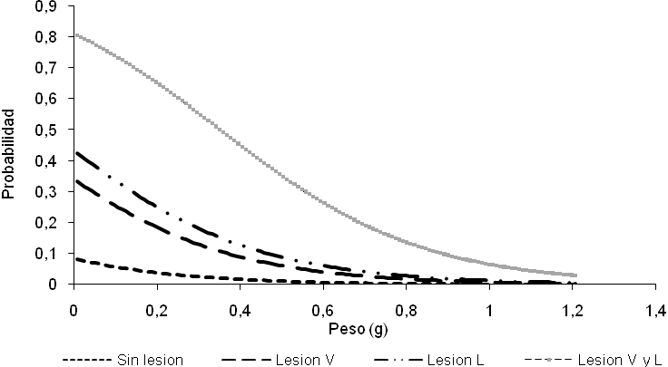
Figure 1. Risk probability of parasitism in C. redtenbacheri larvae in function of weight and position of lesions. Lesion V, ventral lesion; Lesion L, lateral lesion; Lesion V and L, ventral and lateral lesions.

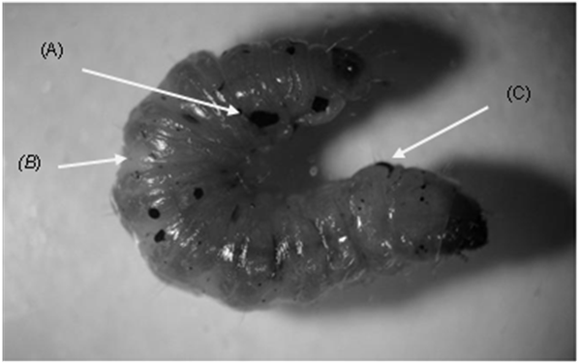

Figure 2. Different lesions in a C. redtenbacheri larvae can be caused by parasitoids (A), pathogens (B), injury or friction (C) among other causes.

