Template for Evidence(s)
UI GreenMetric Questionnaire

University : ...
Country : ...
Web Address : …

[3] Waste (WS)

[3.1] 3R (Reduce, Reuse and Recycle) Program for University Waste
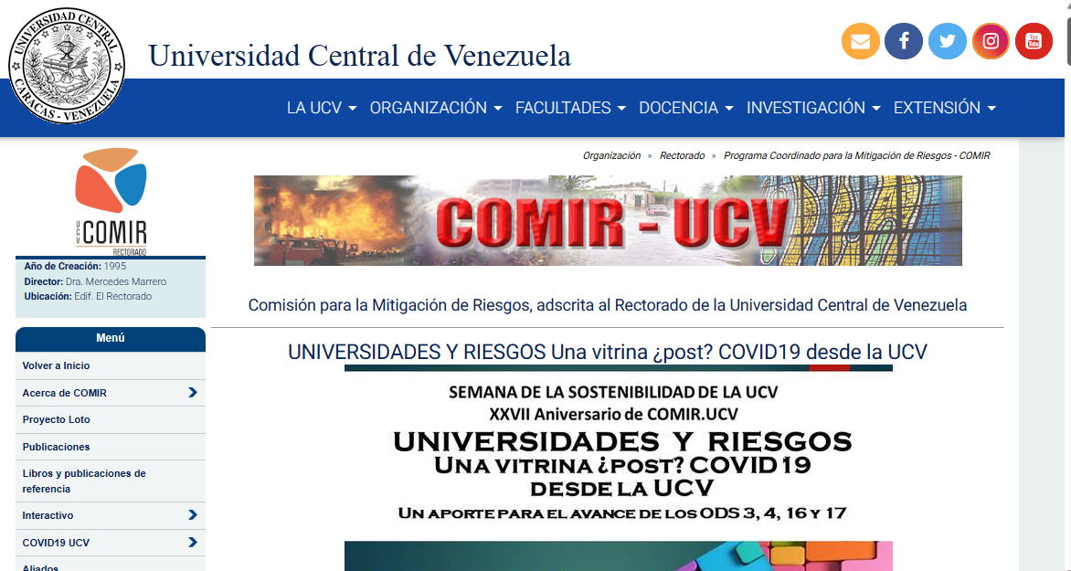
The Commission for Mitigation of Risks

Description:
(Please describe the 3R program on your campus. The following is an example of the description. You can describe more related items if needed.)

3R Programs are not managed by the Faculty of Medicine. However, there is a Commission, called COMIR, adscript to the Rectorate of the UCV, that coordinates such initiatives at the university as a whole.

Additional evidence link (i.e., for videos, more images, or other files that are not included in this file): http://www.ucv.ve/comir

